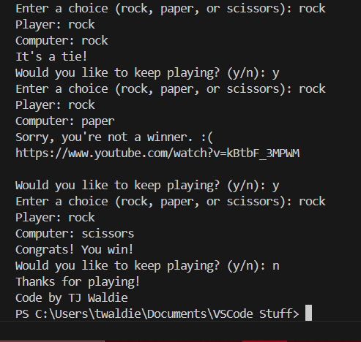

import random

def main():

    options = ("rock", "paper", "scissors")

    playing = True

    while playing:

        player = None

        computer = random.choice(options)

        while player not in options:

            player = input("Enter a choice (rock, paper, or scissors): ").lower()

        print(f"Player: {player}")

        print(f"Computer: {computer}")

        if player == computer:

            print("It's a tie!")

        elif player == "rock" and computer == "scissors":

            print("Congrats! You win!")

        elif player == "paper" and computer == "rock":

            print("Congrats! You win!")

        elif player == "scissors" and computer == "paper":

            print("Congrats! You win!")

        else:

            print("Sorry, you're not a winner. :(")

            print("https://www.youtube.com/watch?v=kBtbF_3MPWM \n")

        play_again = input("Would you like to keep playing? (y/n): ").lower()

        if not play_again == "y":

            playing = False

    print("Thanks for playing! ")

    print("Code by TJ Waldie")

if __name__ == "__main__":

    main()